**Gaining weight: -**

We all have heard that to gain weight, we have to eat more. Eating more food is called “calorie surplus” in the world of fitness.



Gaining weight is not easy, mainly due to these two problems: -

1. *Fast metabolism*: -No matter how much food we eat, our weight didn’t get increased.



1. *Bad appetite*: -Due to which we can’t eat much more than what we eat normally.



Due to these two problems, maintaining yourself in calorie surplus is very difficult. If we focus on our bad appetite then fast metabolism problem will automatically get revoked. To increase your appetite, follow these two steps: -

1. *Drink a lot of water*: -It will increase your stomach capacity to consume good amount of food regularly.
2. *Make sure to consume your first meal of the day as fast as possible*: -It will start working of your appetite very quickly at the beginning of the day. Due to which you can eat more food as time passes within 24 hours of that particular day.

Steps which you should follow to increase your body weight: -

1. *Eating calorie dense food*: -

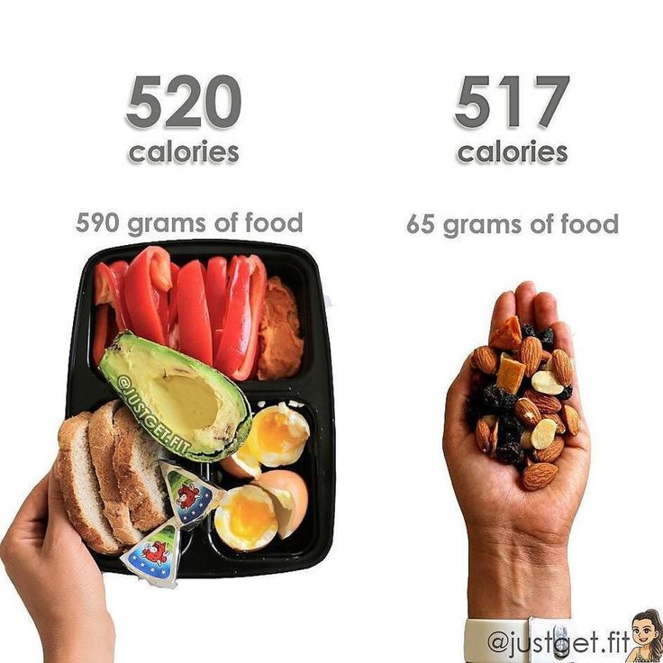

Calorie dense foods are such foods which provides high amount of calorie in low amount. Ex: -Dry fruits, peanut butter, Olive oil, paneer, etc.

Only with 1 tablespoon olive oil or peanut butter, you can easily get 100 calories.

Only with handful amount of dry fruits, you can easily get more than 100 calories.

We can consume these foods very easily.

So, make sure to add these high-density calorie foods, which will help you staying in surplus calorie diet very easily.

1. *High calorie shakes*: -Take 1000 calories in form of a shake in the beginning of your day, i.e., when you wake up.

Steps to prepare a “*dandy shake*”: -

1. Take a jar
2. Add 60 grams of oats
3. 2 tablespoons of peanut butter
4. 300 ml of milk
5. 2 bananas
6. 1-2 tablespoon of honey
7. Mix it
8. Drink it



After that, eat whatever which is prepared in your home. Use any calorie tracking application for monitoring your daily calorie intake.

1. *Workout routine*: -After taking on point diet, its time for hitting gym. The most common mistake what beginners do is following “BRO SPLIT WORKOUT” i.e., training your one muscles only once in a week.



Surely you will get result, but if you follow right strategy then you will get much more results in less time as compared to doing “BRO SPILT”. Train at least 2 times every muscles in every week for better results.

1. *Never use mass gainers*: -

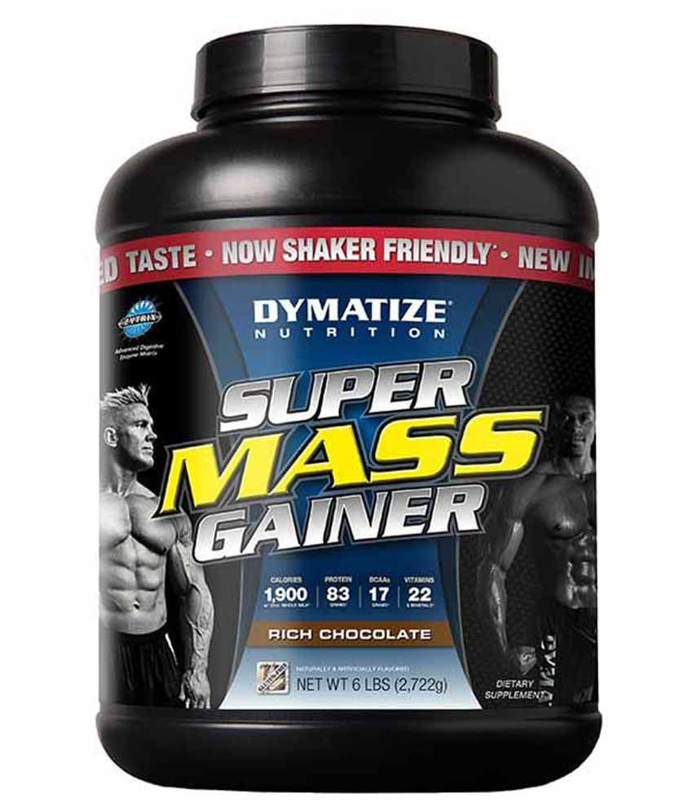

Mass gainers will only provide you short term results. Never use them. Instead use your own “dandy shake”.

1. *8 hours daily sleep*: -No matter how good diet you take, how good exercise you do, appropriate results will come only if your sleep cycle is on point.

**

Try to sleep 8 hours daily. Not continuously, you can take small naps of 45 minutes whenever you get time. Because at the end of day, our progress happens in sleep, not in gym.